**Why Do Startups Without a Store Sell More Than Physical Stores?**

 It’s not luck – it’s **strategy**, and that strategy is [**Digital Marketing**](https://dreambytesolution.com/blog/marketing-without-branding-is-like-Invisible-DMs). This approach is something your competitors are already using to grow their businesses.

**What is Digital Marketing?**

Digital marketing involves promoting your products or services using tools like the internet, social media, search engines, email, and mobile apps. It’s the modern way of connecting with customers through online platforms.

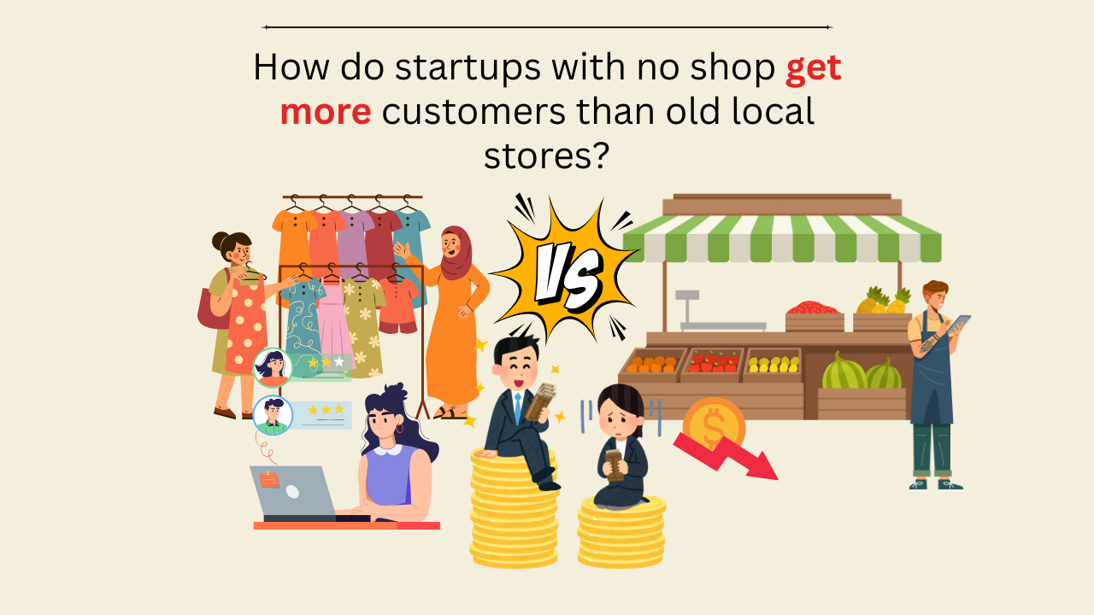

**Key Aspects of Digital Marketing:**

1. **Search Engine Optimization (SEO)**: By improving your website, you can rank higher on search engines, making it easier for people to find your business.
2. **Social Media Marketing**: Using platforms like **Instagram**, **Facebook**, and **TikTok** to share content, engage with your audience, and increase brand awareness.
3. **Content Marketing**: Creating useful and interesting content, like blogs or videos, to attract and keep the right customers.
4. **Email Marketing**: Sending messages directly to customers through email to keep them updated on promotions and news.
5. **Pay-Per-Click (PPC)**: Paying to place ads on search engines or social media, bringing more visibility to your business.
6. **Influencer Marketing**: Working with people who have large followings online to promote your brand to their audience.

**Why Digital Marketing Works:**

* **Global Reach**: The internet connects you with potential customers from anywhere in the world.
* **Cost-Effective**: Digital marketing is often cheaper than traditional methods and allows you to target specific groups of people.
* **Measurable Results**: You can track the performance of your campaigns in real time, which helps you make adjustments as needed.
* **Engagement**: It allows you to have direct conversations with customers, helping you build stronger relationships.

**Example: Mamaearth's Success**

**Mamaearth**, an Indian beauty brand, grew quickly without having a physical store. They used social media, influencer partnerships, and search engine optimization to build a community. Their use of paid ads helped convert website visitors into paying customers. Mamaearth focused on natural, organic products, which helped build trust with their audience.

**Conclusion:**

Digital marketing is a powerful tool for any business. It allows you to reach a global audience, it’s often more affordable than traditional marketing, and it provides the ability to measure and adjust your efforts. If you want to grow your business, digital marketing should be part of your plan.